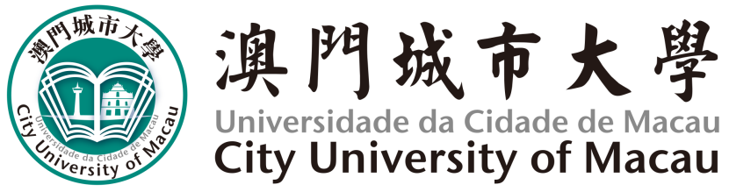

**論文原創聲明**

**DECLARATION FOR ORIGINALITY OF THESIS**

|  |  |
| --- | --- |
| 論文題目 |  |
| Thesis Title |  |

聲明

本人特此聲明，除了經清楚列明來源出處的資料外，其他內容均為原創；本論文的全部或部分未曾在同一學位或其他學位中提交過。

本人聲明知悉《博(碩)士論文寫作指引》、《研究生答辯管理細則》及《澳門城市大學學生紀律規章》。

Declaration

I hereby declare that the thesis here submitted is original except for the source materials explicitly acknowledged and that this thesis, or parts of this thesis have not been previously submitted for the same degree or for a different degree.

I also acknowledge that I am aware of the Rules and Regulations on “[Guideline for Doctoral (Master) Dissertation Writing](http://www.cityu.edu.mo/wp-content/uploads/2016/11/%E5%8D%9A%EF%BC%88%E7%A2%A9%EF%BC%89%E5%A3%AB%E8%AB%96%E6%96%87%E5%AF%AB%E4%BD%9C%E6%8C%87%E5%BC%95.pdf)”, “[Rules on Postgraduate Oral Defense](http://www.cityu.edu.mo/wp-content/uploads/2017/01/%E7%A0%94%E7%A9%B6%E7%94%9F%E7%AD%94%E8%BE%AF%E7%AE%A1%E7%90%86%E7%B4%B0%E5%89%871.pdf)” and “Student Disciplinary Regulations of City University of Macau”.

|  |  |  |
| --- | --- | --- |
|  |  |  |
| 學生簽名Signature of Candidate |  | 日期 Date |
|  |  |  |
| 學生姓名 Name of Candidate |  | 學號 Student Number |
|  |  |  |
| 學院 Faculty |  | 課程 Programme |